gr

Narrative Design Document For:

GESTALT

A choice-driven psychological horror game centred around memory manipulation, accountability, and emotional instability.

All work Copyright ©2026 by Kaito Studios
Written by Lilly-Jane Nicholls (Noah)
Version # 1.00
Saturday, May 23, 2026

Game Overview

Genre & Tone:
Genre -
- Psychological Horror
- Narrative Driven Adventure
Tone -
- Oppressive
- Surreal
- Introspective
- Unsettling

Narrative Premise:
Following his resignation from the police force after a traumatic incident surrounding a car accident causing his wife’s death and sons critical condition, the protagonist spends months hanging around the hospital in hope for his sons recovery, but as time passes he starts to resent him for his wife’s death, wishing it had been him and not her. He eventually snaps and kills his son, being sent to prison on murder charges. After spending X number of years in prison he gets let out on probation due to good behaviour and agrees to undergo an experimental psychological treatment designed to confront suppressed memories. Upon entering the session, he awakens inside a distorted hospital that reflects his guilt, denial, and emotional repression. All his inner phobias and regrets manifested into one big nightmare.
As he progresses deeper into the facility, the environment becomes increasingly unstable, reacting to the player’s behaviour and willingness to confront difficult truths. Avoidance, isolation, and denial shape both the world and the narrative itself.

Core Experience:
Players will:
- Explore a shifting hospital environment influenced by the players ‘mental state’
- Interact with symbolic characters and hostile enemies
- Choose to engage, flee or ignore encounters
- Influence world progression through behavioural patterns rather than explicit morality systems

Target Experience:
The game aims to leave players feeling:
- Emotionally unsettled
- Reflective about guilt, responsibility and denial
- Immersed in a reactive psychological horror experience
- Responsible for the consequences of their behaviour throughout the game

Unique Hook:
To make Gestalt stand out from other games in the psychological horror genre, player tracking has been added as a game mechanic to monitor players choices in the game and change how the narrative expands. This will be placed into a number system named ‘mental state’ the higher the number the more the players surroundings will dynamically change based on behaviour and interaction patterns.
Narrative outcomes will be determined by how the player engages with the world, not just dialogue choices.

Common Questions:
Why create this game?
This game was created to explore guilt, denial, and emotional avoidance through interactive systems rather than passive storytelling. The project aims to use player behaviour as a narrative tool, allowing the world and story to react not only to explicit choices, but to what the player avoids, ignores, or refuses to confront.

Where does the game take place?
The game is set within a reactive hospital environment created through experimental therapy. The setting evolves alongside the protagonist’s psychological state, using environmental distortion and spatial changes to reflect themes of guilt, denial, and avoidance.

What do I control?
Players explore the hospital freely, interacting with characters, environments, and events at their own pace. Encounters can be approached through confrontation, investigation, avoidance, or retreat.

What inspired the core mechanics of this game?
The project initially began as a horror game based around different phobias and fear scenarios. As development progressed, we became more interested in the psychological meaning behind fear rather than the fears themselves.
This led to a shift where enemies and mechanics became symbolic extensions of the protagonist’s feelings and emotional repression. Instead of simply representing things that are scary, encounters were designed to reflect internal struggles and react to player behaviour throughout the game.

World Building

Overview:
The game takes place within a distorted hospital environment created through an experimental psychological treatment. The world reflects the protagonist’s emotional grievances, becoming increasingly unstable as the player progresses. Areas, entities, and environmental changes are tied directly to the protagonist’s mental state and player behaviour.

World Feature #1:
Shifting Architecture-
Areas in the game will physically change based on player behaviour and emotional progression. The narrative purpose for this choice is to create instability, repression and an unreliable narrative. From a gameplay purpose it aims to encourage players to observe their surroundings and make player behaviour feel consequential and significant.
World Feature #2:
Behaviour Reactive Environment-
The world monitors how the player behaves rather than only tracking explicit choices. For example, frequent fleeing of enemies will result in increased hostility and harder combat. Another example would be returning to safe rooms too often within a certain period removes the safety aspect of it. This will reflect in enemies being able to follow you into safe rooms or the save mechanic inside of the safe room failing to work. The narrative purpose for this is making avoidance part of the story itself. From a gameplay purpose it adds unique game mechanics and adds systematic difficulty.

The Physical World:

Key Locations -
- Protagonists Home
Overview:
The protagonist’s house serves as the opening location of the game and acts as a controlled introduction to the world and core gameplay systems. The sequence is intentionally calm and non-threatening, allowing players to absorb the visual style before entering the horror elements of the experience. The location establishes the protagonist’s isolation and emotional state through environmental storytelling, subtle lore placement, and quiet interaction.

Narrative Purpose:
- Foreshadows the game’s main themes of isolation and repression.
- Introduces the protagonist’s personal life.
- Allows the player to find documents containing lore without any threats.

- Hospital
Overview:
The hospital serves as the primary setting of the game and the physical manifestation of the protagonist's mental state. Created through the experimental therapy process, the environment blends reality, memory and psychological distortion into a constantly evolving space.
While initially appearing as a conventional medical facility, the hospital gradually becomes increasingly uncanny as the player progresses. The hospital acts as both the central gameplay space and the primary vehicle for storytelling.

Narrative Purpose:
- Represents the protagonist’s subconscious mind.
- Is the main area and atmosphere for the protagonist to confront his trauma and guilt.
- Reinforces the game’s central themes of responsibility and self-acceptance.
- Provides a physical space where the internal psychological conflicts become perceptible.

- Son’s bedroom:
Overview:
The Son's Bedroom serves as the final location of the game's true ending. Reached after the final confrontation and narrative revelation, the room acts as a space for reflection, acceptance, and emotional closure. Unlike the hostile and distorted environments that precede it, the bedroom is calm, grounded, and free from threat.

The location allows players to process the truth surrounding the protagonist's actions and explore the remnants of a life that was lost.
The room functions as both a narrative reward and a final opportunity for environmental storytelling before the conclusion of the game.

Narrative purpose:
- Serves as an emotional conclusion for the protagonist’s journey.
- Reinforces the reality of actions and consequences.
- Humanises the son behind his role as the final antagonist.

Narrative Delivery and Dialogue

Dialogue Philosophy:
Dialogue is used to communicated narrative information with the player, developing atmosphere and getting across the games themes rather than it being a source of exposition. Dialogue is used to encourage players to engage with NPC’s and objects in the environment emotionally and to use their own interpretation of things.
Conversations will provide an insight of the protagonist’s emotional state and partially reveal the bigger narrative. This will be done with symbolic dialogue or sentences said by NPC’s that almost feel incomplete.
Dialogue will also support player discretion by adding branching dialogue or commonly called multi-choice options. These decisions will contribute to the game behavioural tracking system, influencing how the world responds to the player.

Types of Dialogue:
- NPC Dialogue:
The purpose for this type of dialogue is to deliver narrative information, develop atmosphere and to encourage player engagement. An example would be; players interacting with other patients or symbolic characters.

- Internal Monologue:
The purpose for this would be to reveal the protagonists emotional state about certain objects or environments, providing context for events and showing character development through the narrative. An example of this would be; Reactions to discoveries or key story moments.

- Cutscene Dialogue:
This is dialogue that happens during cutscenes either spoken aloud by the protagonist or when interacting with an NPC, enemy or key character. This could also include flashbacks. The purpose of this would be for delivering major revelations, advancing the narrative or resolving character arcs. An example of this would be; major story reveals.

- Environmental Dialogue:
This could be any type of dialogue that manifests into things such as audio recordings and hallucinations. These are things that the player can interact with but has no control over.

Dialogue Rules:
- Characters will not give direct answers to the player in dialogue, creating a vagueness around the overarching plot. A dialogue example of this could be instead of a character saying, “You killed your son because you blamed him for your wife’s death.” The character would say something like, “You always needed someone to blame.”
- To create the effect of an unreliable character dialogue will always reflect how they feel about a situation rather than what objectively happened. A dialogue example of this could be instead of the protagonist saying, “The accident has left me alone after taking the lives of my wife and kid.” He may say, “My wife promised she’d never leave me, but she did.”
- Dialogue will be less vague coming towards the end of the game as the protagonist starts to accept what has happened and what he has done. It takes the story to another level and allows the narrative to become more grounded. An example of this dialogue could look like,
Son: “You wouldn’t even look at me after the crash.”
Protagonist: “I couldn’t.”
Son: “You wouldn't.”
The dialogue is more direct at the protagonist and doesn’t hide behind metaphors or ambiguity.
- Silence is dialogue. There will be many times in the game where there aren’t characters to speak with, or the player can interact with. This is to cause moments of silence not only to make the player feel a sense of isolation but a symbol of the protagonist’s inability to communicate or a refusal to acknowledge.

Example Dialogue:
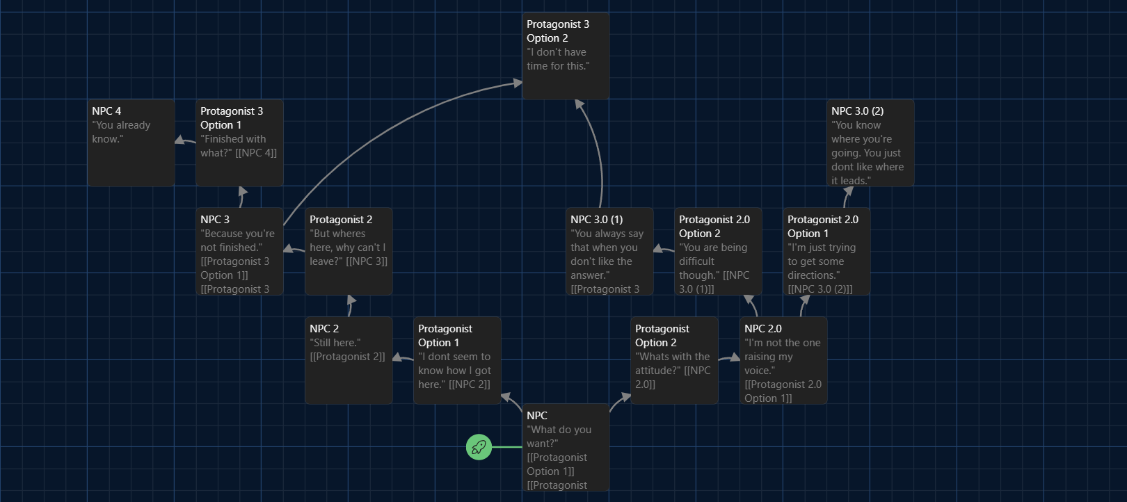
The protagonist has come across an NPC after the therapy simulation has failed.

Character Profiles

